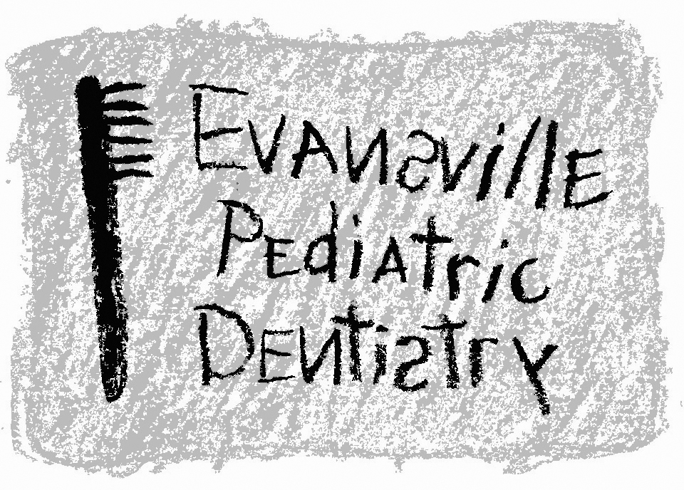
Jeffrey A. Hiester, D.D.S.
EAST WEST
7200 E. Virginia Street 2345 W. Franklin Street #101
Evansville, IN 47715 Evansville, IN 47712
(812) 479-8609 (812) 401-6095

Instructions After Treatment

Local Anesthetic
- The local anesthetic that your child received “numbs” the lips, cheeks, and tongue in the area of treatment. This may be a puzzling or curious sensation for a youngster, but care must be taken that your child does not bite, suck, or chew their lips or tongue. Lacerations (cuts) to the tissue could occur. While this is not serious, it is most uncomfortable for the child when the “numbness” wears off.
- Please monitor your child very closely for approximately 1-2 hours. Avoid eating until the anesthetic has “worn off.”

Extractions
- Following dental surgery it is normal to experience some discomfort. If medication is needed, choose a pain reliever that doesn’t contain aspirin.
- It is normal for saliva to be slightly streaked with blood for 1-2 days. If abnormal bleeding occurs, place gauze over extraction area and instruct your child to bite down for 15 minutes. Repeat if necessary.
- No drinking through a straw for 24 hours.
- On the morning following surgery, rinse mouth with warm salt water (1/4 teaspoon salt to a glass of warm water). Repeat this several times daily.
- Do not engage in vigorous exercise for 24 hours.
- Do not rinse for at least 4 hours.
- Begin brushing the extraction area the morning following the procedure.

Restorative Treatment (Fillings)
- Following restorative treatment it is normal to experience some discomfort. If medication is needed, an appropriate over-the-counter medication will help alleviate any pain.
- Medication taken immediately following appointment will help your child tolerate the transition from being numb.
- If the filling was large or close to the nerve, your tooth may be sensitive when the anesthetic wears off.
- Care should be exercised when eating extremely hot or cold foods or drinks.
- Your child may rinse their mouth with warm salt water (1/4 teaspoon salt to a glass of warm water). Repeat this several times daily as needed.
- If a new crown was placed, your child may need a few days to adjust to it.
- Do not eat anything hard or sticky.
- Care for your child’s new filling with proper brushing and flossing. It is especially important to keep the edge of the fillings/crowns clean at the gumline.

Sealants
- Avoid hard, sticky or chewy foods (taffy, starburst, gummy worms, etc.
- Sealants will checked at regular visits and “touched up” as necessary

Space Maintainers
- Be sure to brush along the gumline where the bands are placed. Plaque can collect easily in that area and cause the gums to hurt.
- Avoid hard, sticky or chewy foods (taffy, starburst, gummy worms, etc). These foods cause the spacer to come loose.
- If the spacer becomes loose or comes out entirely, make an appointment as soon as possible to have the spacer recemented. The teeth may move quickly and cause the spacer to not fit.

